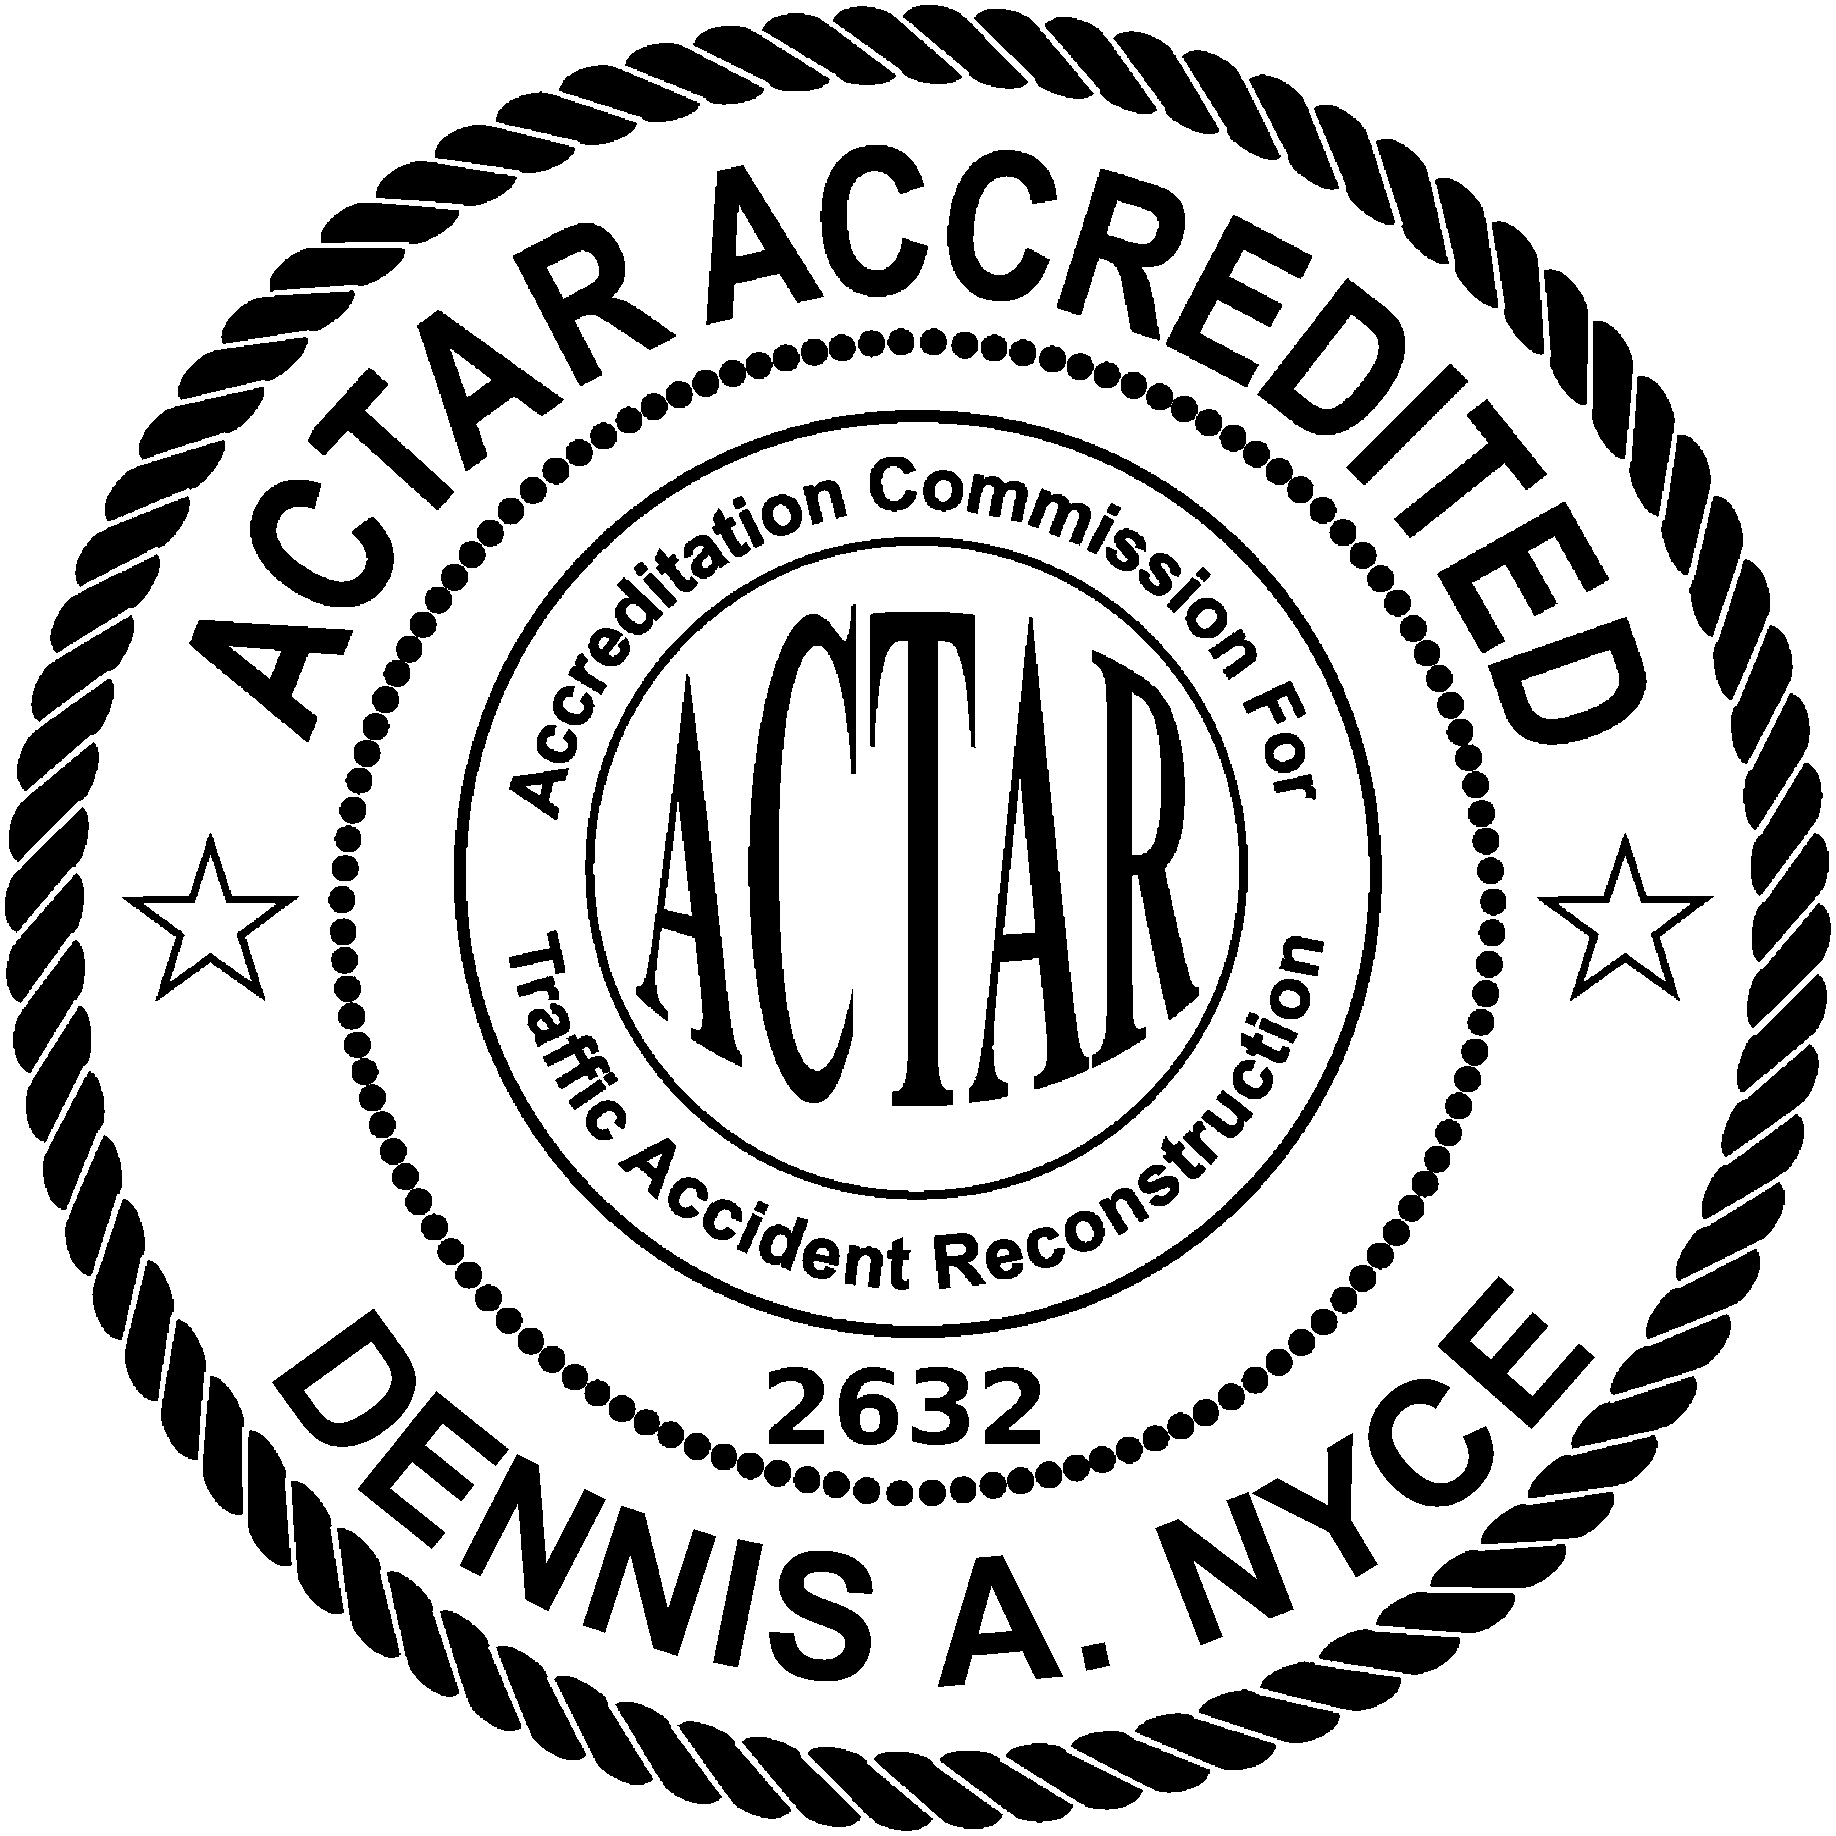 ***Curriculum Vitae***

**Dennis A. Nyce**

[**dnyce@impactcrash.com**](mailto:dnyce@impactcrash.com)

**(216) 334-7573**

**Work Experience**

**Impact Crash Reconstruction, LLC May 2021-Present**

* President and Founder
* Accident Reconstruction / Expert

**Chagrin Falls Police Department 1998-Present**

* Full-Time Police Officer – As an officer in a small police department my everyday duties include general patrol. Additional duties include completing many follow investigations which would be handled by detectives in a larger agency.
* I have been assigned to Accident Investigation Unit (VEG AIU) since 2004 (still currently active) and the Bicycle Patrol Unit from 2002 until 2020.
* I am responsible for reviewing and approving all accident reports completed by our department.
* I organized and ran our annual police bicycle rodeo in conjunction with the Safe Routes to School Program for several years. Our goal was to promote and teach children safe bicycling practices to assure the safety of the children within our community.
* I have the honor of being our department’s first K-9 handler in 2020 (to present.)
  + I attended an intense, six-week training course at Shallow Creek Kennels in PA.
  + I work with a German Shepherd who is certified in Narcotic Detection and Patrol Services.
  + I am required to recertify yearly and attend two, 8-hour trainings per month. Training records are available upon request.
  + Certifications are held with Ohio Peace Officer Training Academy (OPOTA) and North American Police Work Dog Association (NAPWDA).

**Valley Enforcement Group, Accident Investigation Unit (VEG AIU)**  **2004-Present**

* Team Commander of VEG AIU as of January 1, 2018.
* Assistant Team Commander and founding member of the VEG AIU in 2004.
* VEG AIU responds to serious injury and/or fatal motor vehicle accidents for 15 municipalities within Cuyahoga, Geauga and Summit counties. This area covers over 150 square miles. This is part of my duties as a Chagrin Falls Police Officer.
  + VEG AIU responds to the active crash scene to complete the on-scene investigation and detailed reconstruction reports.
  + As of September of 2021, VEG AIU has responded to ~158 calls for service, of these calls, ~62 were fatalities. Over this time our investigations have led to ~97 criminal charges being filed against the “at fault” drivers and we have maintained a 100% conviction rate.
  + VEG AIU conducts in-service training (8 Hours) every other month. I organize and instruct the majority of the VEG AIU trainings.

**Introtech Crash Reconstruction Services** **2011-2021**

* Accident Reconstruction
* I spent about 10 years learning how to investigate, document, and testify on serious injury and fatal crashes on both the civil, and criminal sides.

**Twinsburg Police Department** **1992-1999**

* Part-time police, fire and EMS dispatcher (1997-1999)
* Police Explorer / Police Cadet (1992-1997)

**Boston Heights Police Department 1997-1998**

* Part-Time Police Officer

**Accreditation, Education and Training**

**ACTAR Accreditation** **July 2, 2014**

* Accreditation Commission for Traffic Accident Reconstructionist
* *ACTAR Accreditation #2632* – In good standing.

**Lakeland Community College** **1995-1997**

* Associate of Applied Science; Criminal Justice
* Ohio Police Officer Training Academy

**Ohio Peace Officer Training Commission (O.P.O.T.A.)**

* Drag Factor Determination for Traffic Investigator (16 hours) **March 2014**
* First Line Supervision **July 2009**
* Forensic Mapping for the Traffic Collision Investigator (24 hours) **March 2011**
* Traffic Collision Reconstruction Update **November 2010**
* Testifying in Court **May 2005**
* Evidence Room Management (16 hours) **November2005**
* Vehicle Energy/Crush Deformation Reconstruction (24 hours) **September 2005**
* Crash Reconstruction (80 hours) **November 2004**
* Vehicle Dynamics 2000 (40 hours) **October 2004**
* Traffic Crash Investigation, Level II (80 hours) **July 2004**
* Traffic Crash Investigation, Level I (80 hours) **February 2004**
* Investigation and Reconstruction of Pedestrian and **July/August 2018**
* Bicycle Involved Collisions (40 hours)

**Institute of Police Technology and Management (IPTM)**

* Fundamental Techniques of Crash Investigation (8 hours / VOD) **December 2021**
  + Case Preparation (testifying as an expert)
  + Lamp Examination
  + Tire Examinations
  + Roadway Evidence
  + Safety Belts

**North Coast Polytechnic Institute**

* Motorcycle Accident Reconstruction (24 hours) **May 2009**
* Pedestrian Accident Investigation/Reconstruction (24 hours) **November 2006**
* Expert Testimony in Accident Reconstruction (9 hours) **March 2006**

**Vericom Computers, Inc.**

* Acceleration and Vericom Familiarization (12 hours) **December 2006**
* Vericom Certified Operator; VC4000 & Profile 5 Analysis (16 hours) **November 2018**

**FARO – Geo Shack**

* FARO Focus 3-D Laser Scanner Training (5.5 hours) **November 2013**
* Topcon ES-105 Total Station/Magnet (4 hours) **November 2013**

**Cuyahoga Community College**

* Urban Police Mountain Bicycle Techniques (40 hours) **April 2002**

**Introtech Crash Reconstruction Services**

* Traffic Reconstruction Update (24 hours) **December 2012**
* Two-hour introduction to ARAS 360 **December 2011**
* Insurance Institute for Highway Safety: **December 2016**

Understanding Car Crashes: When Physics meet Biology

(1 Hour Training Video)

* National Safety Council (On-Line course with test) **December 2016**

NSC Defensive Driving Course 9th Edition (2.5 hours)

* Temporary Traffic Control for Work Zones  **January 2017**

Seminar at Lorain City Hall (2.5 hours)

* Conservation of Momentum and Expert Court Testimony **September 2017**

(8 Hour Training at Russell PD on 09/08/2017)

**State of Ohio, Attorney General’s Office: E-OPOTA On-Line Training**

* Interviewing the Crime Victim **September 2008**
* Automobile Inventory **February 2012**
* Automobile Searches **February 2012**
* OH-1 Crash Report Update **November 2012**
* Death Notification **December 2014**
* Operating a Vehicle Impaired (OVI) Statutory Review **November 2016**

**We Bike etc. and Bike Cleveland**

* 16-hour seminar on Bicycle / Pedestrian Safety and Enforcement **April 2014**

**Northwestern University – Center for Public Safety**

* Crash Data Recorder System Technician Level I & 2 (16 hours) **April 2015**
* Crash Data Retrieval – Data Analyst (40 hours) **April 2017**

**Crash Academy**

* How to Use the Bosch CDR Pro Tool Kit (5 hours) **July 2021**
* How to Perform a CDR Direct-to-Module Download (2 hours) **July 2021**

**Additional training**

* First Responder to HAZ-MAT, Radar Speed Measurements, Standardized Field Sobriety Testing, Advanced Traffic Stops and Tactics, Advanced Interview and Interrogation, BAC DataMaster, Mobile Video Instructor, O.C./Pepper Spray, ASP, Taser, LEAD’s Operator, and several legal updates.

**Other**

* On May 17, 2021, I instructed four, 8th Grade algebra classes at Brady Middle School in Moreland Hills, Ohio. The purpose of this instruction was to show the students how the algebra they were learning is used in real police crash investigations. The class was successful, and we plan to repeat this training in the future.
* On May 2, 2018, and May 22, 2019, I instructed an eight-hour block of a basic traffic crash investigation course for William D. Healy of North Coast Polytechnic Institute. I covered the following topics: basic math review, critical speed calculations, minimum speed calculations, airborne speed calculations, calculating drag factors, vehicle damage patterns, and technology advancements in traffic crash investigation.
* I have participated as a rider in “Pedal to the Point”, now known as the “Buckeye 150” between 2009 and 2016. This is an organized bicycle event that includes thousands of riders each year who ride 150 miles over two days. This event raised money for M.S.
* In May of 2016 I was accepted into Law Enforcement United (LEU) which is a group consisting of hundreds of full-time law enforcement professionals who ride bicycles from various locations and meet in Washington D.C. The purpose of this group is to raise awareness and funds to support the families of police officers who were killed in the line of duty. The various groups ride an average of 250 miles over the three-day period. I’m a member of the PA division which starts its journey from Reading, Pennsylvania. I successfully completed this well-organized bicycle ride for several years, 2016-present, and I have made the necessary arrangement to continue my participation with LEU.
* July 26, 2012, I was accepted as a member of the National Association of Traffic Accident Reconstructionist and Investigators. (NATARI)
* In November of 2011 I was recognized as an “Expert Witness” in Cuyahoga County, Court of Common Pleas for a civil case. This case was a fatal MVA which I was the lead investigator on with VEG AIU in 2009. I testified for about 3 hours in front of a jury, which agreed with our original findings in this investigation.
  + Judge Richard J. McMonagle / Case #CV 10 725505.
* Several of my investigations (VEG AIU) have led to successful convictions of numerous individuals on various levels of criminal Vehicle Homicide charges.
* I have received multiple letters of accommodation from the Chagrin Falls PD, Gates Mills PD, and Russell PD for accident-related investigations I have completed.
* I completed a 16-hour course sponsored by Motorcycle Ohio. This course is overseen by the Ohio Department of Public Safety and consisted of 4 hours of classroom training and 12 hours of on-cycle training at Lakeland CC on March 27-29, 2015. I successfully completed a written and driving test and was awarded my motorcycle endorsement in the state of Ohio.